**A comparison of the US GDP growth forecast results**

1. Comparison of forecasts in the 2001 recession (2001:I – 2001:IV)
   1. Pre-crisis models
   2. Post-crisis models
   3. Structural models versus time-series models
2. Comparison of forecasts in the 2008/09 recession (2008:III – 2009:II)
   1. Pre-crisis models
   2. Post-crisis models
   3. Structural models versus time-series models
3. Comparison of forecasts in the current recession (2020:I – 2020:II)
   1. Pre-crisis models
   2. Post-crisis models
   3. Structural models versus time-series models
4. Comparison of forecasts from the original DNGS15 model and a modified DNGS15 model with less nominal rigidities
5. Comparison of forecasts from models estimated based on rolling-window and expanding-window specifications

* **Comparison of forecasts in 2001:I – 2001:IV**
* **Pre-crisis models**

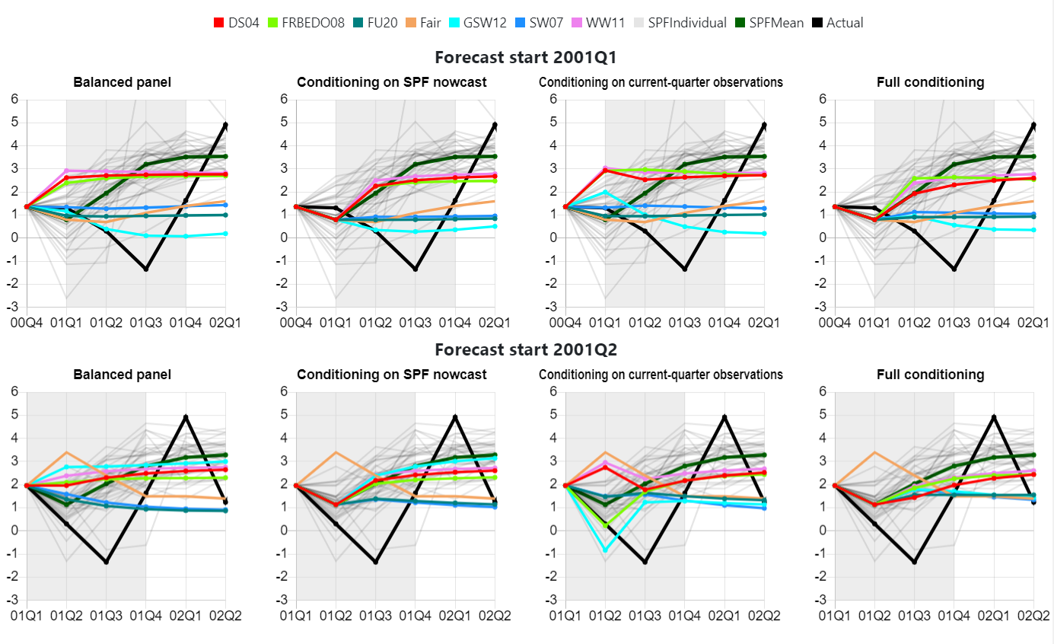

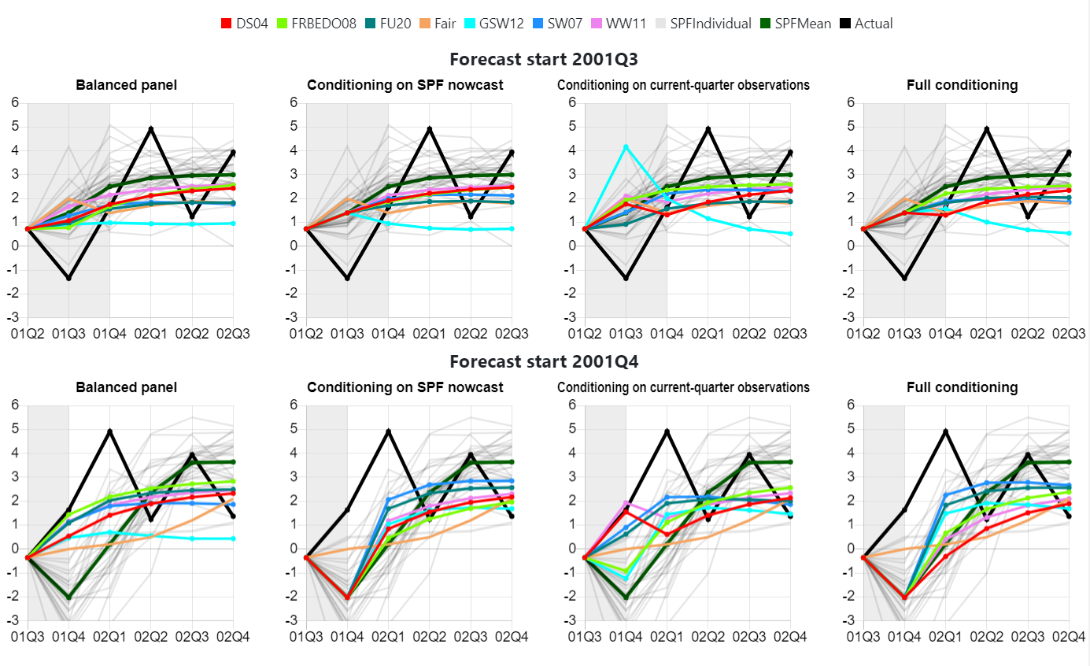

* **Comparison of forecasts in 2001:I – 2001:IV**
* **Post-crisis models**

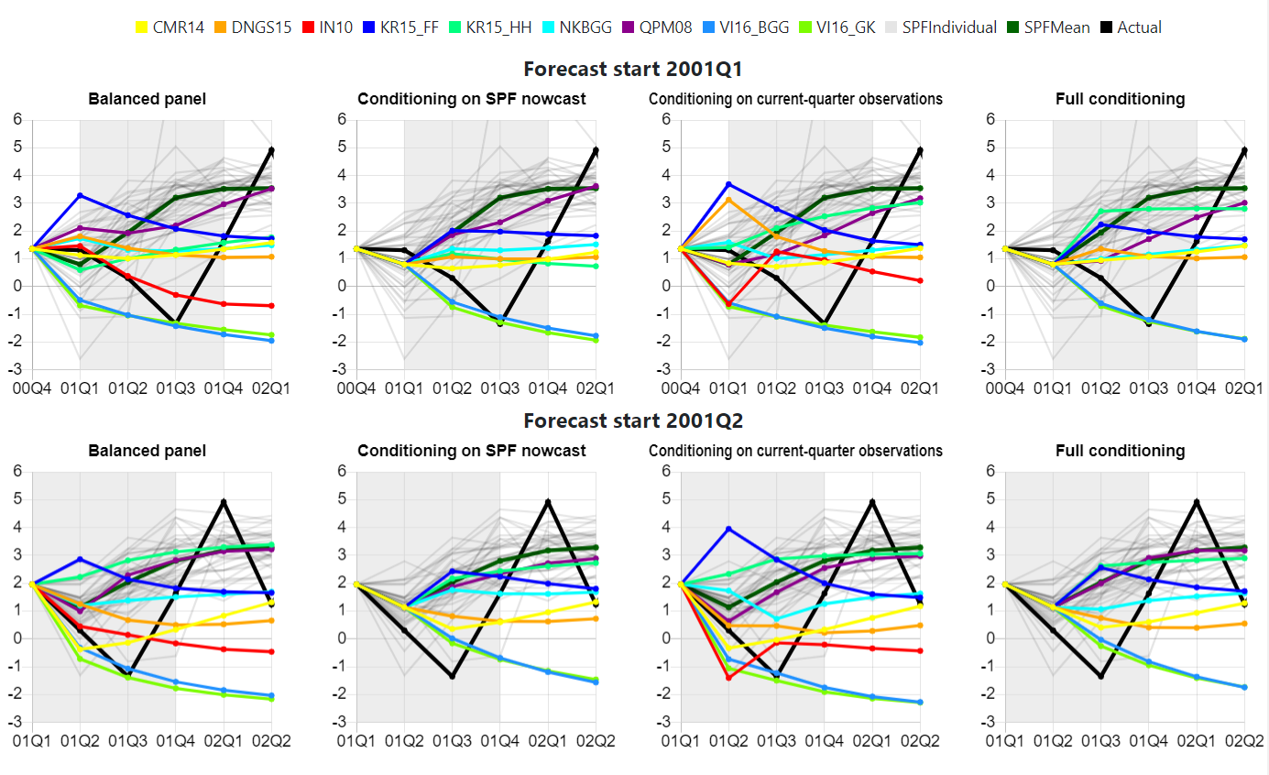

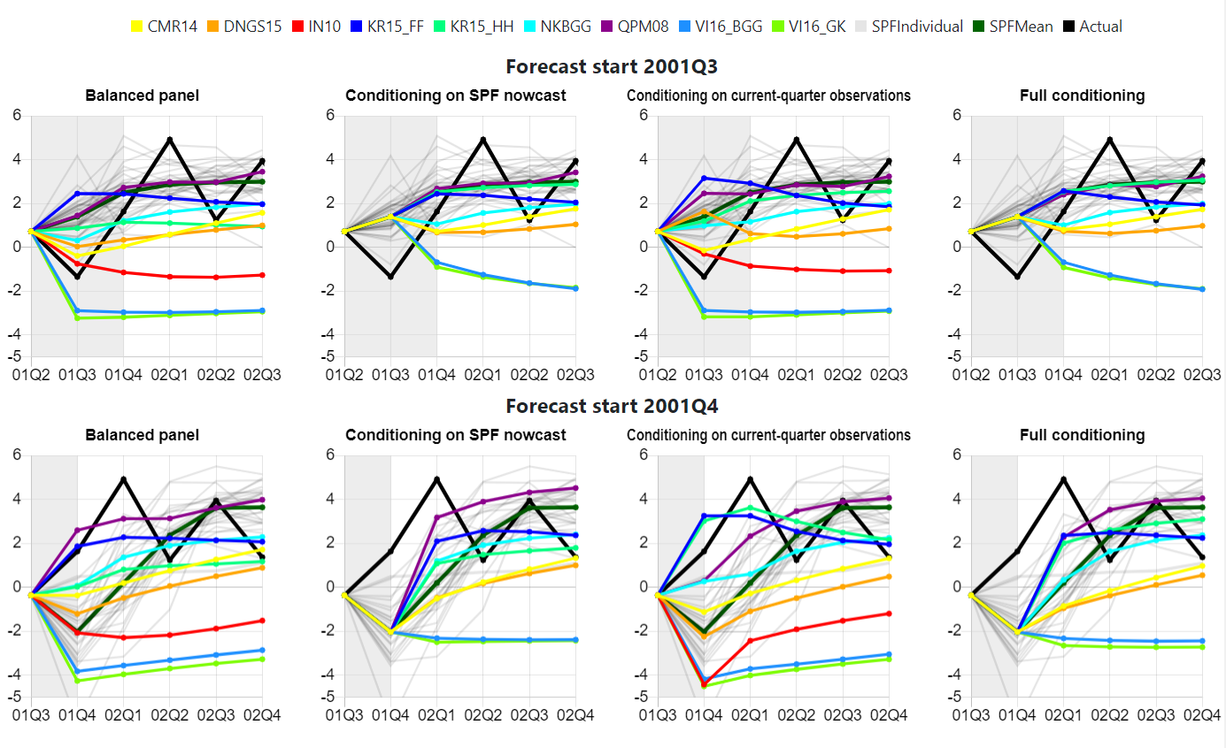

* **Comparison of forecasts in 2001:I – 2001:IV**
* **Structural models versus time-series models**

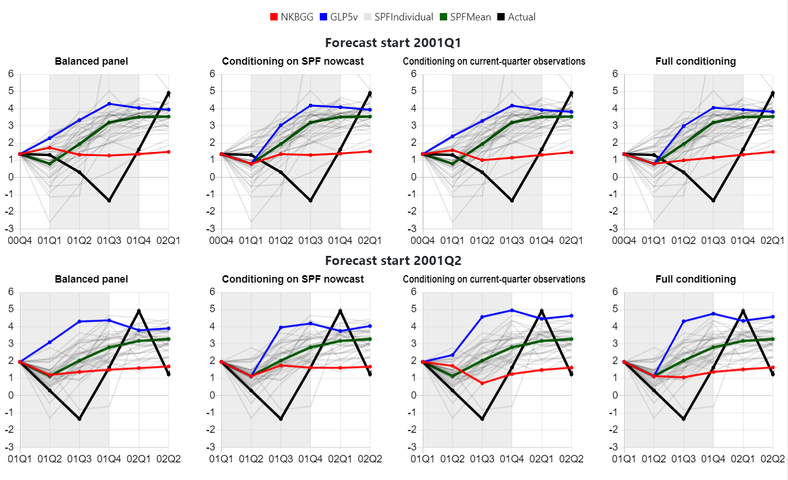

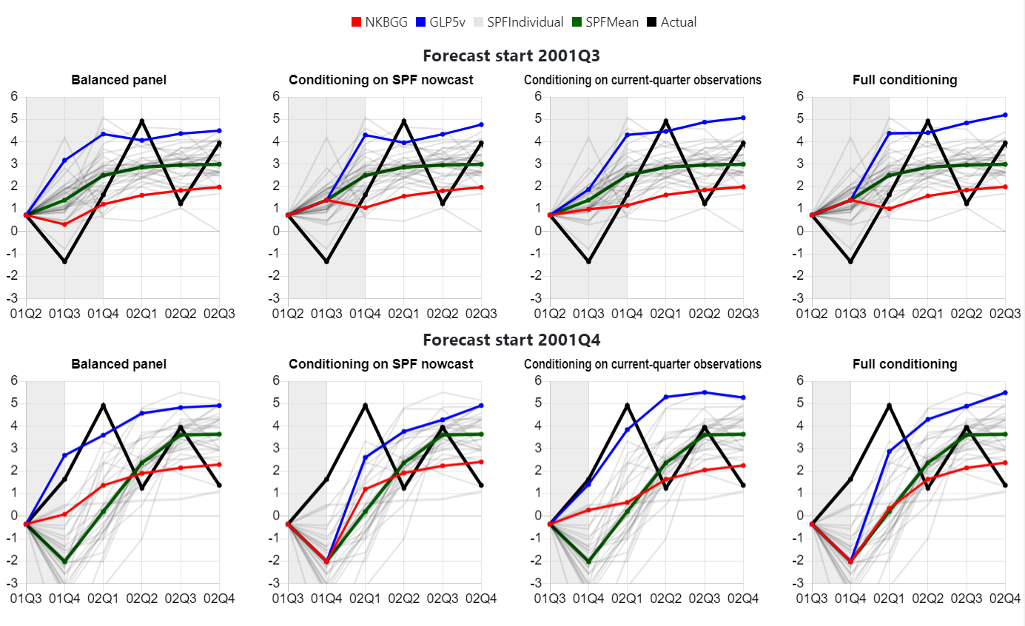

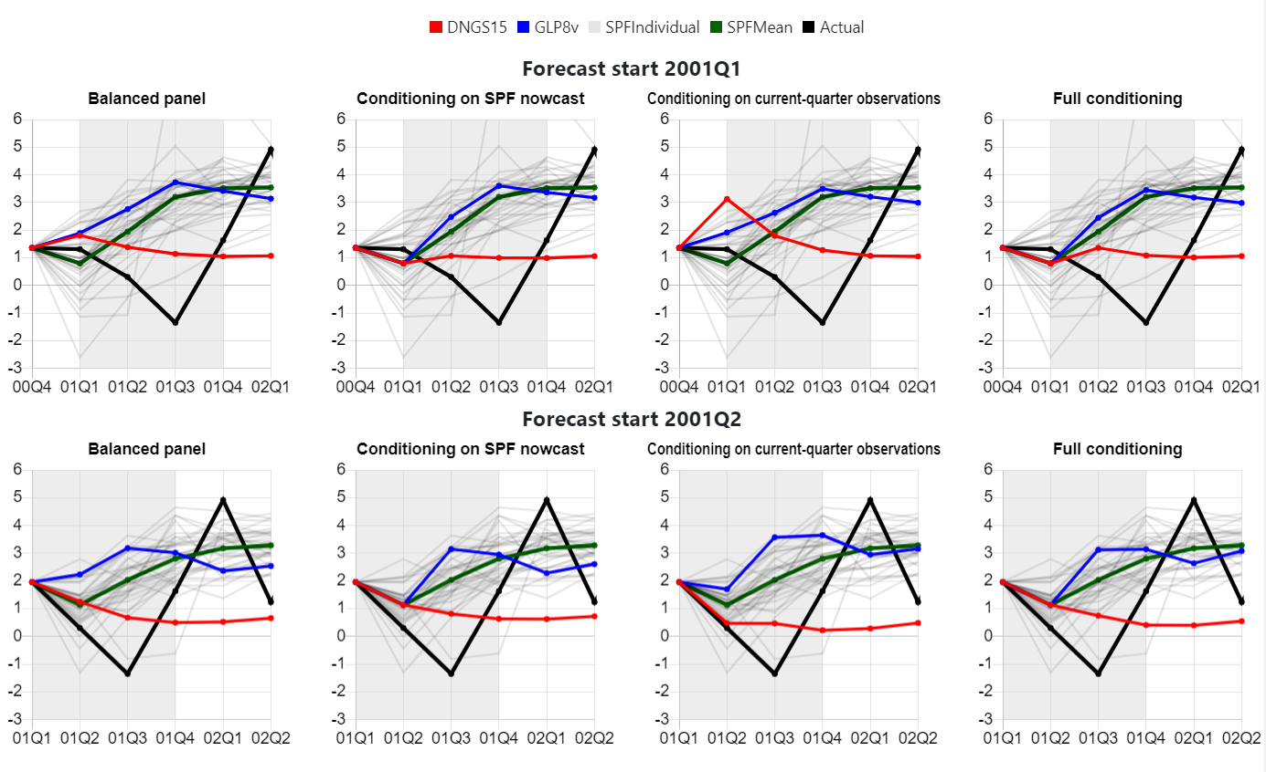

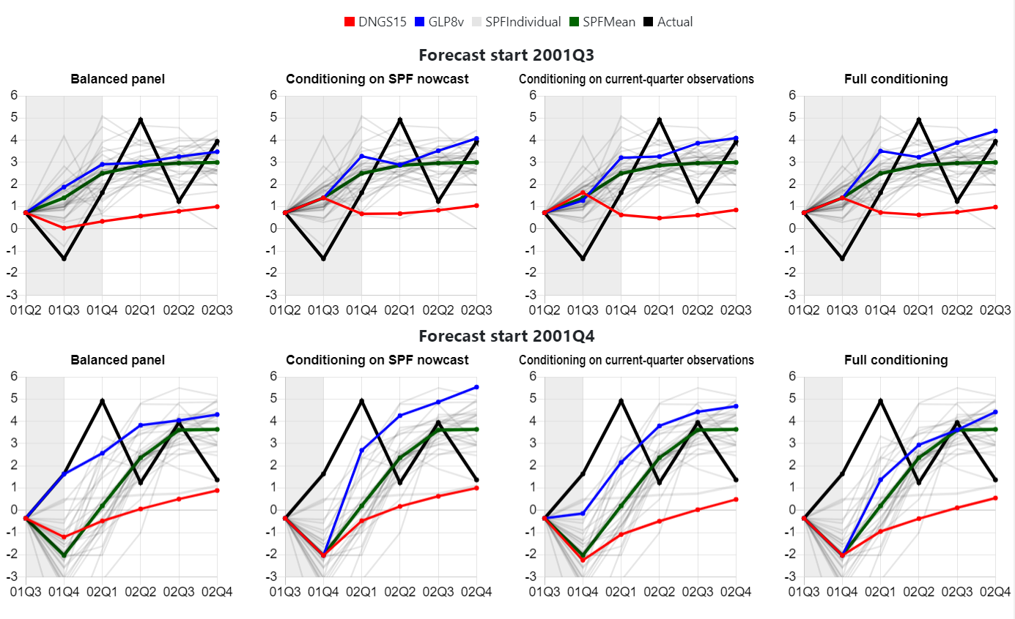

* **Comparison of relative* RMSEs in 2001:I – 2001:IV**

* RMSEs are reported relative to those of the RMSE of the mean SPF forecast, for which absolute RMSEs are reported in the last column.

|  |  |  |  |  |  |  |  |  |  |  |  |  |  |  |  |  |  |  |  |  |  |  |  |  |  |  |
| --- | --- | --- | --- | --- | --- | --- | --- | --- | --- | --- | --- | --- | --- | --- | --- | --- | --- | --- | --- | --- | --- | --- | --- | --- | --- | --- |
| Source | | SW07 | | | | DS04 | | | | WW11 | | | | FU20 | | | | GSW12 | | | | FRBEDO08 | | | | Fair |
| Scenario | | BP | SPF | CQ | FC | BP | SPF | CQ | FC | BP | SPF | CQ | FC | BP | SPF | CQ | FC | BP | SPF | CQ | FC | BP | SPF | CQ | FC |  |
| Horizon | 0 | 0.64 |  | 0.66 |  | 0.72 |  | 0.91 |  | 0.86 |  | 1.00 |  | 0.56 |  | 0.59 |  | 0.76 |  | 1.36 |  | 0.64 |  | 0.95 |  | 1.04 |
| 1 | 0.68 | 0.66 | 0.69 | 0.69 | 0.92 | 0.94 | 0.95 | 1.01 | 0.93 | 0.95 | 0.94 | 0.98 | 0.63 | 0.70 | 0.70 | 0.70 | 0.97 | 0.89 | 0.72 | 0.77 | 0.83 | 0.97 | 0.92 | 0.96 | 0.99 |
| 2 | 0.79 | 0.74 | 0.74 | 0.78 | 0.97 | 0.91 | 0.96 | 0.91 | 0.97 | 0.93 | 0.97 | 0.93 | 0.78 | 0.74 | 0.76 | 0.74 | 0.85 | 0.88 | 0.81 | 0.84 | 0.97 | 0.89 | 0.94 | 0.91 | 0.78 |
| 3 | 1.45 | 1.33 | 1.42 | 1.20 | 1.07 | 1.11 | 1.14 | 1.22 | 1.04 | 1.07 | 1.08 | 1.15 | 1.41 | 1.32 | 1.32 | 1.22 | 1.40 | 1.04 | 1.49 | 1.35 | 1.06 | 1.20 | 1.12 | 1.12 | 1.43 |
| 4 | 1.19 | 1.32 | 1.15 | 1.32 | 0.90 | 0.89 | 0.89 | 0.89 | 0.89 | 0.89 | 0.88 | 0.87 | 1.32 | 1.36 | 1.28 | 1.32 | 1.70 | 1.66 | 1.67 | 1.64 | 0.91 | 0.89 | 0.89 | 0.91 | 1.16 |
|  |  |  |  |  |  |  |  |  |  |  |  |  |  |  |  |  |  |  |  |  |  |  |  |  |  |  |
| Source | | NKBGG | | | | QPM08 | | | | DNGS15 | | | | CMR14 | | | | KR15_FF | | | | KR15_HH | | | |  |
| Scenario | | BP | SPF | CQ | FC | BP | SPF | CQ | FC | BP | SPF | CQ | FC | BP | SPF | CQ | FC | BP | SPF | CQ | FC | BP | SPF | CQ | FC |  |
| Horizon | 0 | 0.53 |  | 0.66 |  | 0.67 |  | 0.87 |  | 0.71 |  | 1.11 |  | 0.50 |  | 0.66 |  | 0.71 |  | 1.38 |  | 0.71 |  | 0.76 |  |  |
| 1 | 0.76 | 0.82 | 0.80 | 0.86 | 0.74 | 0.67 | 0.68 | 0.72 | 0.99 | 0.97 | 1.07 | 1.05 | 0.85 | 0.95 | 0.91 | 1.00 | 0.99 | 1.21 | 1.10 | 1.21 | 1.00 | 1.21 | 0.71 | 1.21 |  |
| 2 | 0.81 | 0.82 | 0.79 | 0.80 | 0.88 | 0.95 | 0.86 | 0.86 | 1.00 | 0.96 | 1.07 | 1.02 | 0.99 | 0.89 | 0.93 | 0.93 | 0.91 | 0.83 | 0.98 | 0.86 | 0.88 | 0.67 | 0.99 | 0.93 |  |
| 3 | 1.23 | 1.21 | 1.28 | 1.25 | 0.91 | 1.02 | 0.88 | 0.80 | 1.81 | 1.76 | 1.97 | 1.92 | 1.57 | 1.63 | 1.68 | 1.71 | 1.19 | 1.04 | 1.11 | 1.07 | 1.12 | 1.24 | 0.83 | 1.03 |  |
| 4 | 1.17 | 1.17 | 1.17 | 1.17 | 1.03 | 1.10 | 1.07 | 1.11 | 1.41 | 1.40 | 1.46 | 1.43 | 1.18 | 1.23 | 1.20 | 1.18 | 1.07 | 1.08 | 1.12 | 1.10 | 1.41 | 1.28 | 0.95 | 0.92 |  |
|  |  |  |  |  |  |  |  |  |  |  |  |  |  |  |  |  |  |  |  |  |  |  |  |  |  |  |
| Source | | IN10 | | | | VI16_BGG | | | | VI16_GK | | | | 3vBVAR | | | | 5vBVAR | | | | 8vBVAR | | | | SPF |
| Scenario | | BP | SPF | CQ | FC | BP | SPF | CQ | FC | BP | SPF | CQ | FC | BP | SPF | CQ | FC | BP | SPF | CQ | FC | BP | SPF | CQ | FC | Mean |
| Horizon | 0 | 0.80 |  | 1.42 |  | 1.28 |  | 1.36 |  | 1.41 |  | 1.46 |  | 1.43 |  | 1.16 |  | 1.18 |  | 0.85 |  | 0.81 |  | 0.75 |  | 2.34 |
| 1 | 1.29 |  | 1.30 |  | 1.60 | 1.27 | 1.62 | 1.27 | 1.67 | 1.31 | 1.68 | 1.33 | 1.12 | 1.08 | 1.19 | 1.14 | 1.16 | 1.14 | 1.19 | 1.17 | 0.95 | 0.94 | 1.03 | 1.05 | 3.05 |
| 2 | 1.41 |  | 1.40 |  | 1.84 | 1.43 | 1.87 | 1.45 | 1.91 | 1.46 | 1.92 | 1.50 | 1.31 | 1.27 | 1.42 | 1.31 | 1.36 | 1.27 | 1.45 | 1.33 | 1.18 | 1.20 | 1.16 | 1.06 | 2.62 |
| 3 | 2.76 |  | 2.58 |  | 3.58 | 3.14 | 3.67 | 3.20 | 3.68 | 3.16 | 3.72 | 3.28 | 1.38 | 1.32 | 1.50 | 1.39 | 1.35 | 1.33 | 1.48 | 1.42 | 1.19 | 1.29 | 1.18 | 1.23 | 1.55 |
| 4 | 2.40 |  | 2.16 |  | 3.18 | 2.88 | 3.23 | 2.93 | 3.21 | 2.90 | 3.23 | 2.96 | 1.34 | 1.41 | 1.61 | 1.55 | 1.31 | 1.35 | 1.55 | 1.60 | 1.06 | 1.36 | 1.23 | 1.17 | 1.74 |

* **Comparison of forecasts in 2008:III – 2009:II**
* **Pre-crisis models**

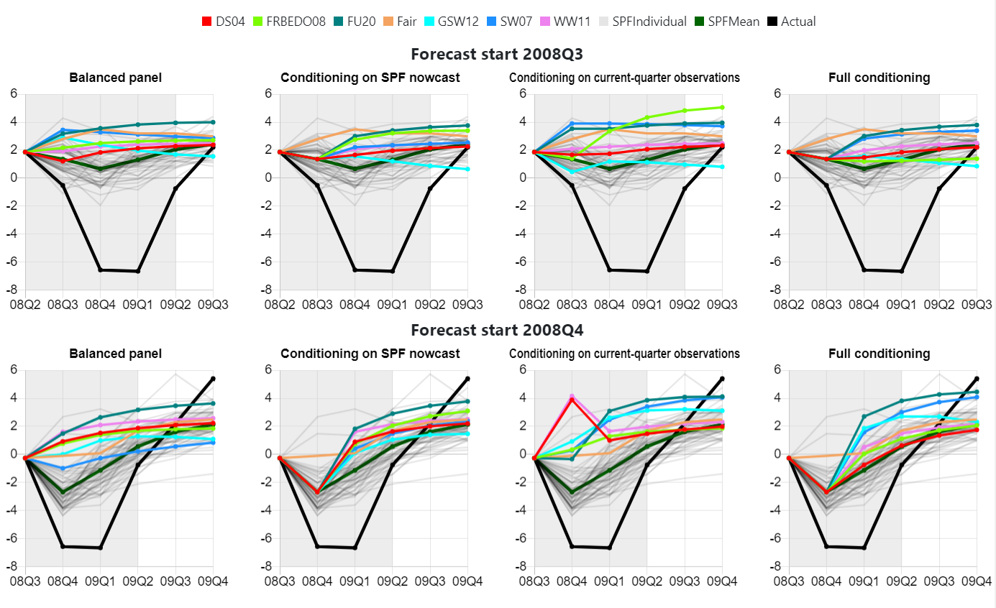

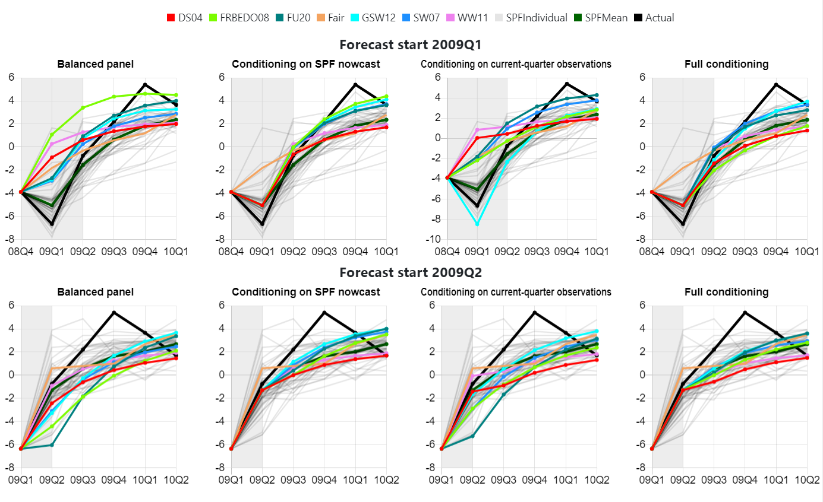

* **Comparison of forecasts in 2008:III – 2009:II**
* **Post-crisis models**

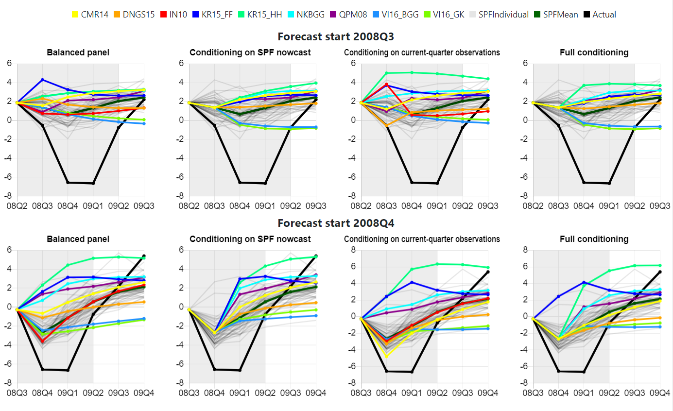

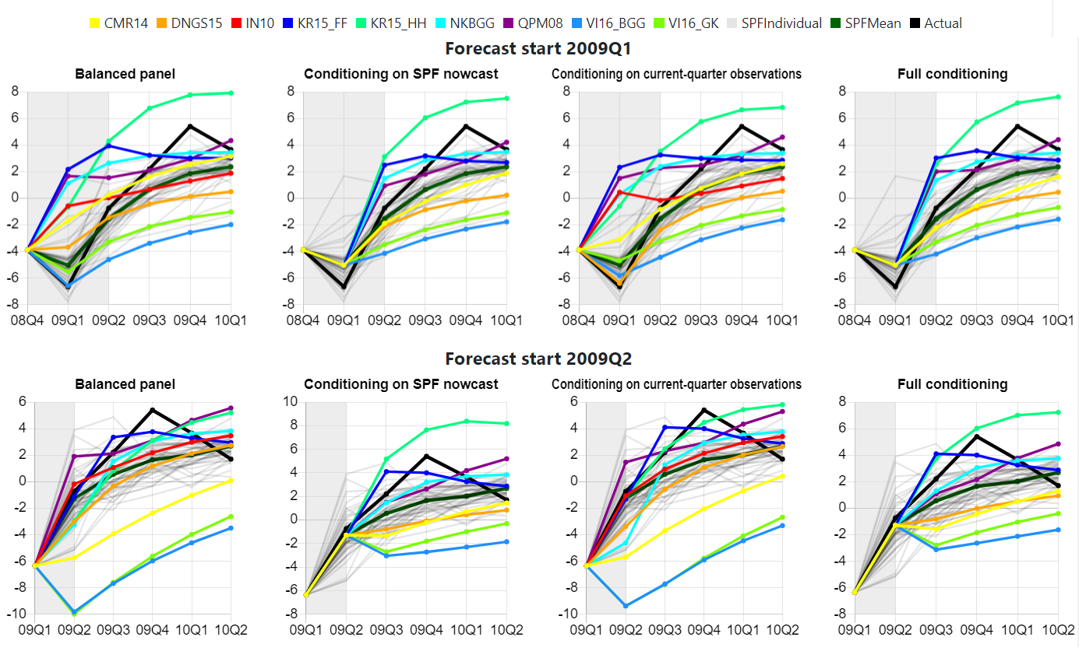

* **Comparison of forecasts in 2008:III – 2009:II**
* **Structural models versus time-series models**

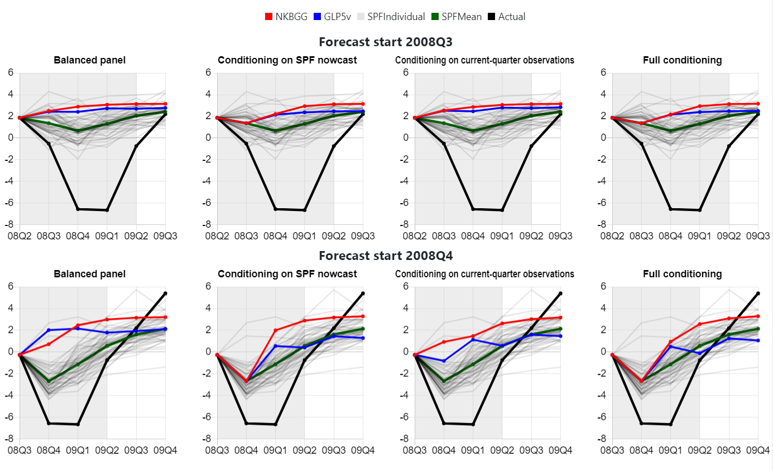

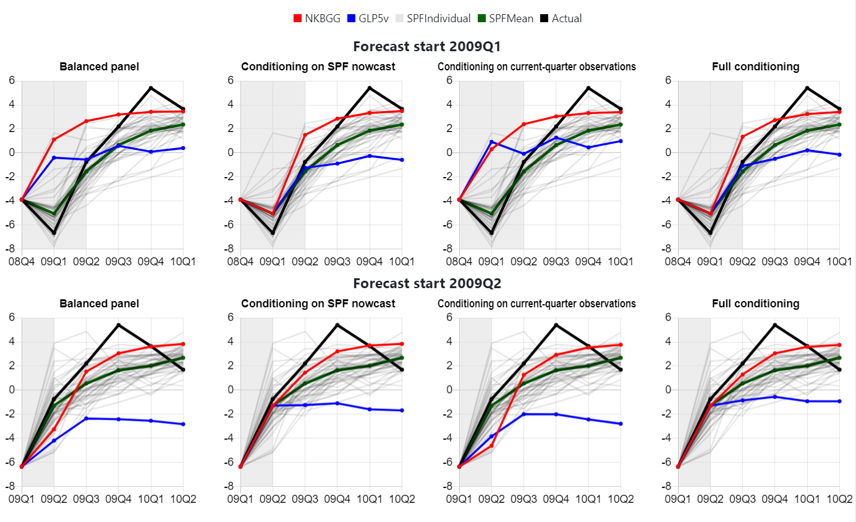

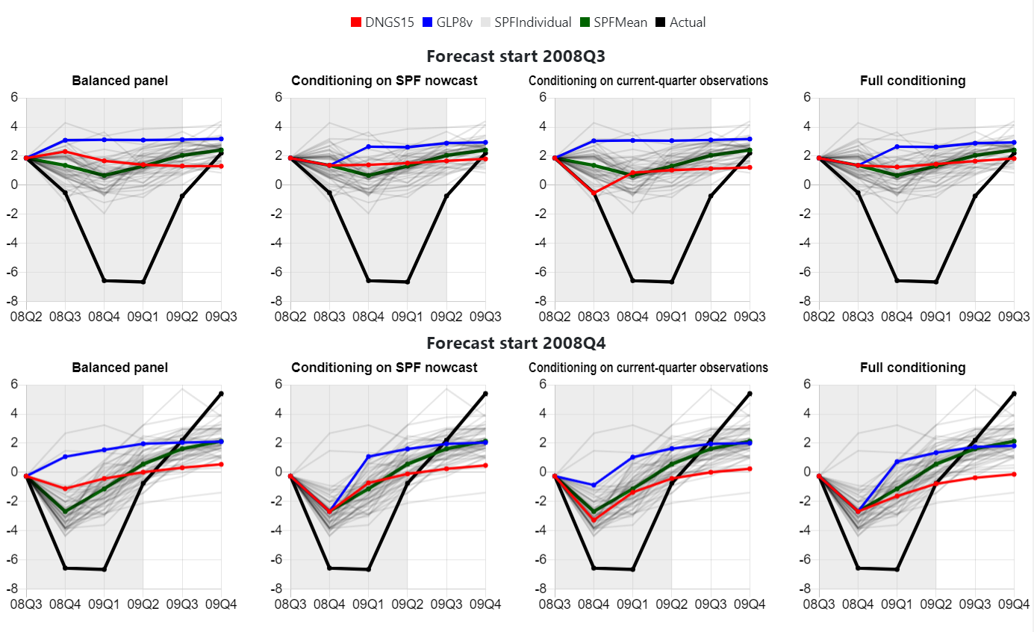

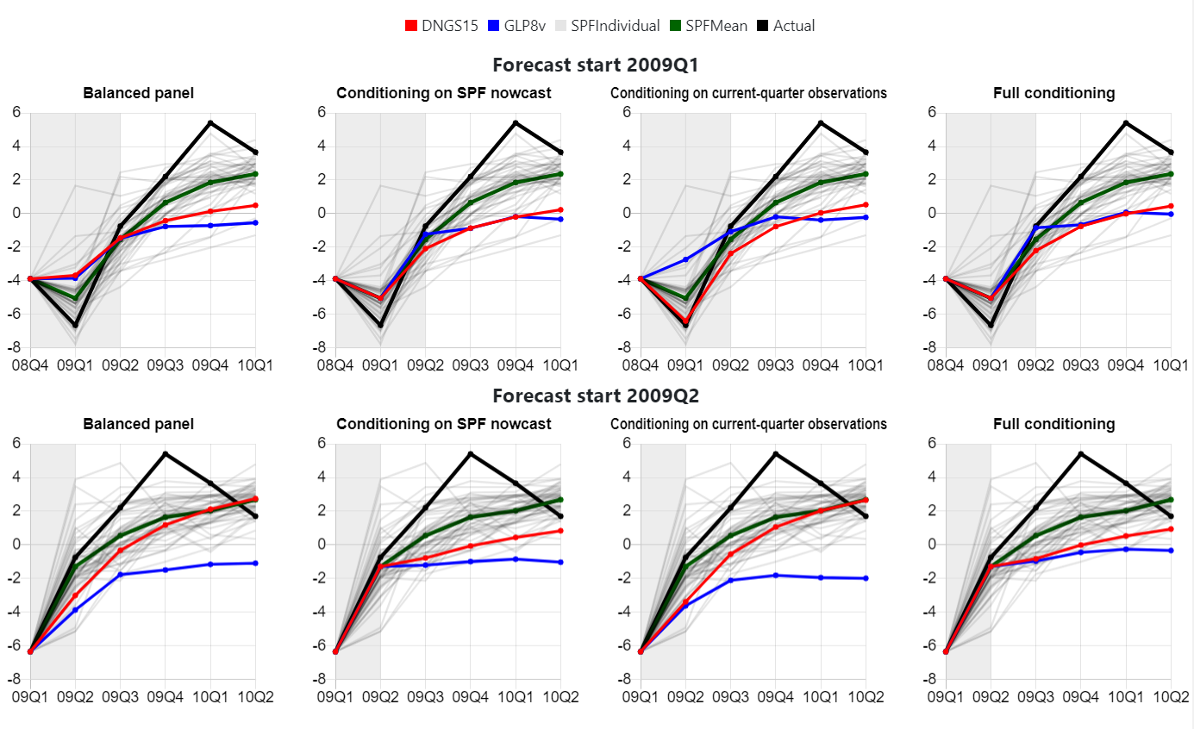

* **Comparison of relative* RMSEs in 2008:III – 2009:II**

* RMSEs are reported relative to those of the RMSE of the mean SPF forecast, for which absolute RMSEs are reported in the last column.

|  |  |  |  |  |  |  |  |  |  |  |  |  |  |  |  |  |  |  |  |  |  |  |  |  |  |  |
| --- | --- | --- | --- | --- | --- | --- | --- | --- | --- | --- | --- | --- | --- | --- | --- | --- | --- | --- | --- | --- | --- | --- | --- | --- | --- | --- |
| Source | | SW07 | | | | DS04 | | | | WW11 | | | | FU20 | | | | GSW12 | | | | FRBEDO08 | | | | Fair |
| Scenario | | BP | SPF | CQ | FC | BP | SPF | CQ | FC | BP | SPF | CQ | FC | BP | SPF | CQ | FC | BP | SPF | CQ | FC | BP | SPF | CQ | FC |  |
| Horizon | 0 | 1.76 |  | 2.06 |  | 2.10 |  | 2.72 |  | 2.37 |  | 2.88 |  | 2.38 |  | 2.15 |  | 1.88 |  | 1.69 |  | 2.50 |  | 1.88 |  | 1.91 |
| 1 | 1.30 | 1.22 | 1.53 | 1.36 | 1.31 | 1.23 | 1.27 | 1.12 | 1.37 | 1.30 | 1.34 | 1.23 | 1.55 | 1.39 | 1.59 | 1.46 | 1.31 | 1.15 | 1.33 | 1.28 | 1.45 | 1.31 | 1.41 | 1.14 | 1.32 |
| 2 | 1.19 | 1.08 | 1.32 | 1.22 | 1.16 | 1.12 | 1.15 | 1.12 | 1.15 | 1.14 | 1.15 | 1.14 | 1.34 | 1.23 | 1.37 | 1.28 | 1.06 | 0.94 | 1.04 | 1.04 | 1.24 | 1.21 | 1.35 | 1.04 | 1.24 |
| 3 | 1.08 | 0.82 | 1.11 | 1.04 | 1.11 | 1.13 | 1.14 | 1.22 | 1.05 | 1.09 | 1.08 | 1.14 | 1.11 | 1.06 | 1.12 | 1.16 | 0.73 | 0.55 | 0.77 | 0.63 | 0.89 | 0.94 | 1.40 | 1.06 | 1.21 |
| 4 | 1.30 | 1.00 | 0.66 | 0.59 | 0.98 | 1.02 | 1.06 | 1.17 | 0.89 | 0.93 | 0.96 | 1.03 | 0.83 | 0.88 | 0.73 | 0.74 | 1.31 | 1.33 | 0.95 | 1.06 | 1.02 | 0.89 | 1.28 | 1.11 | 0.99 |
|  |  |  |  |  |  |  |  |  |  |  |  |  |  |  |  |  |  |  |  |  |  |  |  |  |  |  |
| Source | | NKBGG | | | | QPM08 | | | | DNGS15 | | | | CMR14 | | | | KR15_FF | | | | KR15_HH | | | |  |
| Scenario | | BP | SPF | CQ | FC | BP | SPF | CQ | FC | BP | SPF | CQ | FC | BP | SPF | CQ | FC | BP | SPF | CQ | FC | BP | SPF | CQ | FC |  |
| Horizon | 0 | 2.45 |  | 2.45 |  | 2.57 |  | 2.39 |  | 1.55 |  | 0.91 |  | 2.04 |  | 1.42 |  | 1.98 |  | 2.89 |  | 1.98 |  | 2.62 |  |  |
| 1 | 1.46 | 1.35 | 1.39 | 1.27 | 1.34 | 1.30 | 1.30 | 1.30 | 1.15 | 1.13 | 1.04 | 1.07 | 1.41 | 1.25 | 1.24 | 1.18 | 1.55 | 1.13 | 1.56 | 1.43 | 1.49 | 1.13 | 1.63 | 1.13 |  |
| 2 | 1.19 | 1.16 | 1.17 | 1.15 | 1.06 | 1.08 | 1.05 | 1.09 | 1.05 | 1.14 | 1.03 | 1.13 | 1.38 | 1.25 | 1.33 | 1.23 | 1.21 | 1.05 | 1.21 | 1.09 | 1.32 | 1.07 | 1.52 | 1.26 |  |
| 3 | 0.92 | 0.93 | 0.93 | 0.94 | 0.86 | 0.86 | 0.80 | 0.86 | 1.27 | 1.48 | 1.30 | 1.48 | 1.39 | 1.33 | 1.41 | 1.38 | 0.87 | 0.85 | 0.91 | 0.80 | 1.04 | 1.23 | 1.46 | 1.28 |  |
| 4 | 0.88 | 0.86 | 0.87 | 0.85 | 1.26 | 1.14 | 1.26 | 1.15 | 1.63 | 1.66 | 1.69 | 1.76 | 0.94 | 0.93 | 1.11 | 1.13 | 0.83 | 0.87 | 0.87 | 0.86 | 1.38 | 2.11 | 1.49 | 1.81 |  |
|  |  |  |  |  |  |  |  |  |  |  |  |  |  |  |  |  |  |  |  |  |  |  |  |  |  |  |
| Source | | IN10 | | | | VI16_BGG | | | | VI16_GK | | | | 3vBVAR | | | | 5vBVAR | | | | 8vBVAR | | | | SPF |
| Scenario | | BP | SPF | CQ | FC | BP | SPF | CQ | FC | BP | SPF | CQ | FC | BP | SPF | CQ | FC | BP | SPF | CQ | FC | BP | SPF | CQ | FC | Mean |
| Horizon | 0 | 1.49 |  | 1.96 |  | 2.19 |  | 2.09 |  | 2.20 |  | 2.09 |  | 2.58 |  | 2.61 |  | 2.49 |  | 2.26 |  | 2.03 |  | 1.79 |  | 2.32 |
| 1 | 0.99 |  | 0.99 |  | 1.47 | 1.11 | 1.48 | 1.13 | 1.42 | 1.06 | 1.45 | 1.06 | 1.38 | 1.26 | 1.37 | 1.26 | 1.44 | 1.28 | 1.36 | 1.26 | 1.44 | 1.35 | 1.41 | 1.32 | 4.64 |
| 2 | 0.92 |  | 0.90 |  | 1.60 | 1.26 | 1.57 | 1.26 | 1.54 | 1.14 | 1.54 | 1.13 | 1.28 | 1.19 | 1.23 | 1.16 | 1.39 | 1.28 | 1.34 | 1.24 | 1.39 | 1.32 | 1.39 | 1.28 | 4.52 |
| 3 | 0.94 |  | 0.99 |  | 2.50 | 2.13 | 2.44 | 2.09 | 2.28 | 1.83 | 2.25 | 1.80 | 1.47 | 1.42 | 1.39 | 1.33 | 1.83 | 1.73 | 1.78 | 1.59 | 1.80 | 1.66 | 1.85 | 1.56 | 2.42 |
| 4 | 1.11 |  | 1.20 |  | 2.86 | 2.60 | 2.82 | 2.60 | 2.60 | 2.26 | 2.55 | 2.30 | 1.22 | 1.51 | 1.17 | 1.46 | 1.78 | 1.86 | 1.80 | 1.74 | 1.67 | 1.62 | 1.75 | 1.53 | 1.83 |

* **Comparison of forecasts in 2020:I – 2020:III\***
* **Pre-crisis models**

* The actual GDP growth in 2020:I – 2020:II are collected as of August 27, 2020.

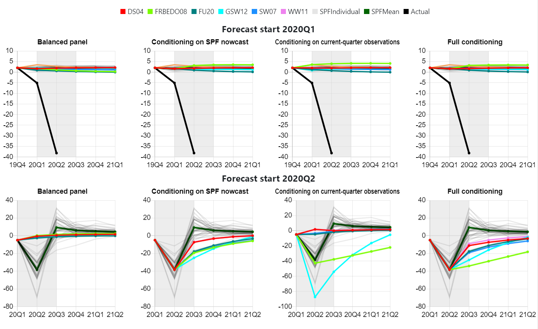

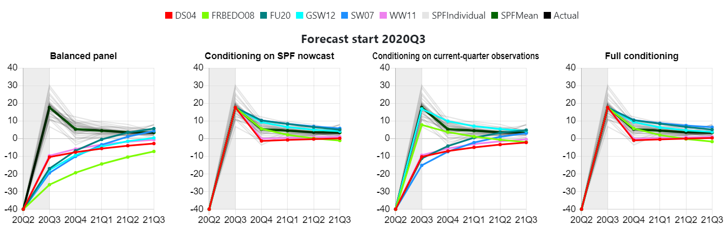

* **Comparison of forecasts in 2020:I – 2020:III\***
* **Post-crisis models**

* The actual GDP growth in 2020:I – 2020:II are collected as of August 27, 2020.

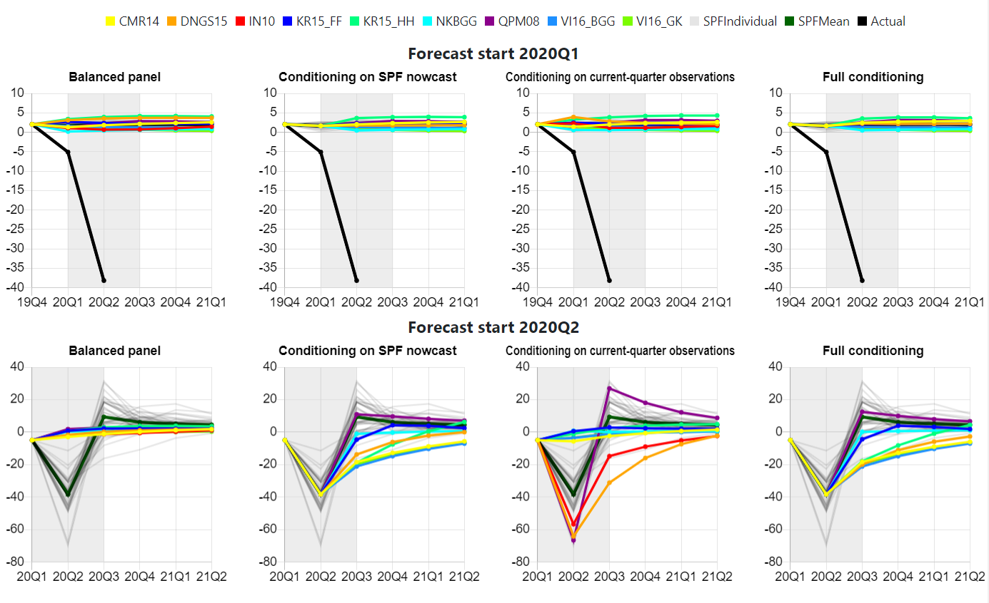

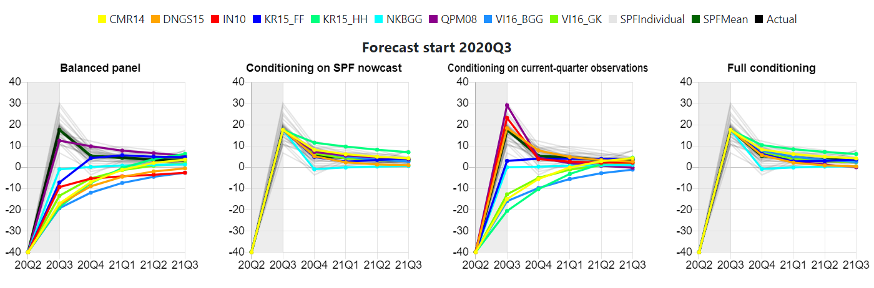

* **Comparison of forecasts in 2020:I – 2020:III\***
* **Structural models versus time-series models**

* The actual GDP growth in 2020:I – 2020:II are collected as of August 27, 2020.

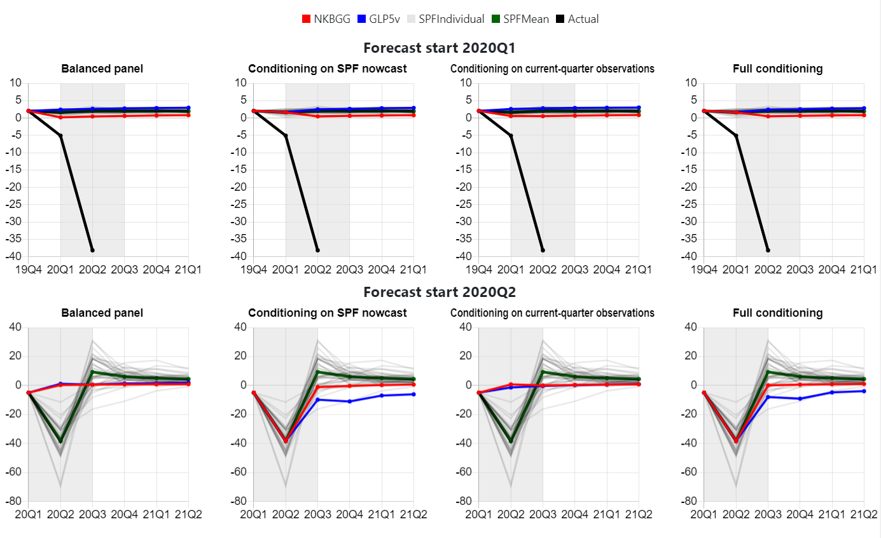

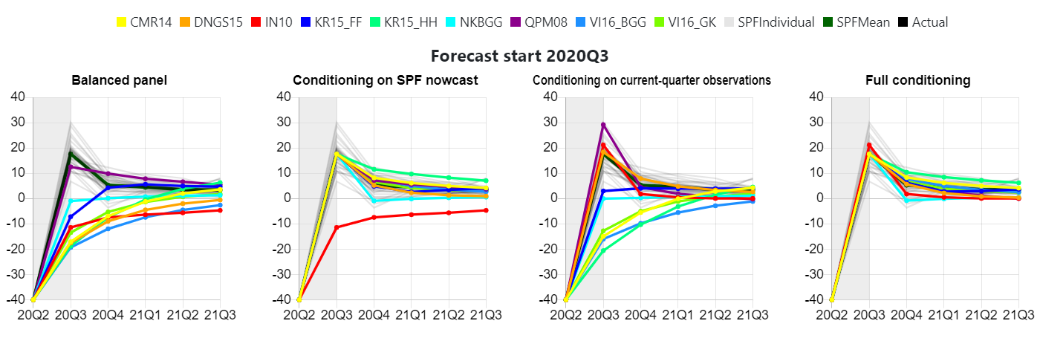

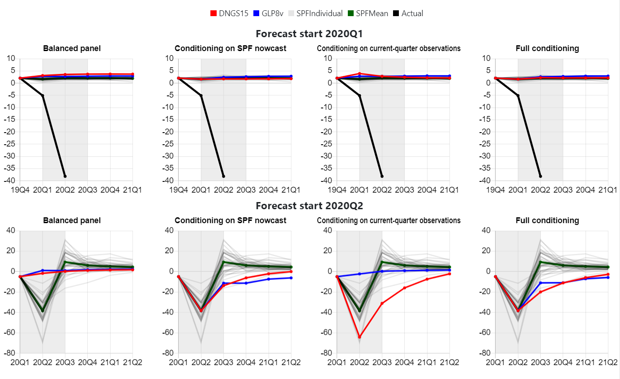

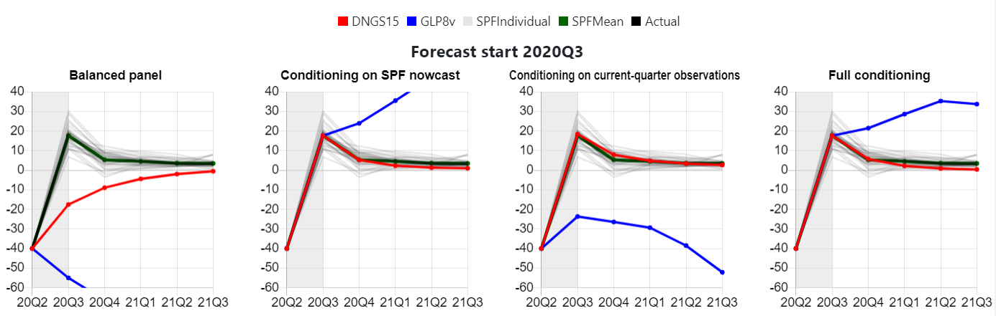

* **Comparison of forecast and relative* RMSEs from the original DNGS15 model and a modified DNGS15 model with less nominal rigidities**
* **Forecast period: 2008:III – 2009: II**

* RMSEs are reported relative to those of the RMSE of the mean SPF forecast, for which absolute RMSEs are reported in the last column.

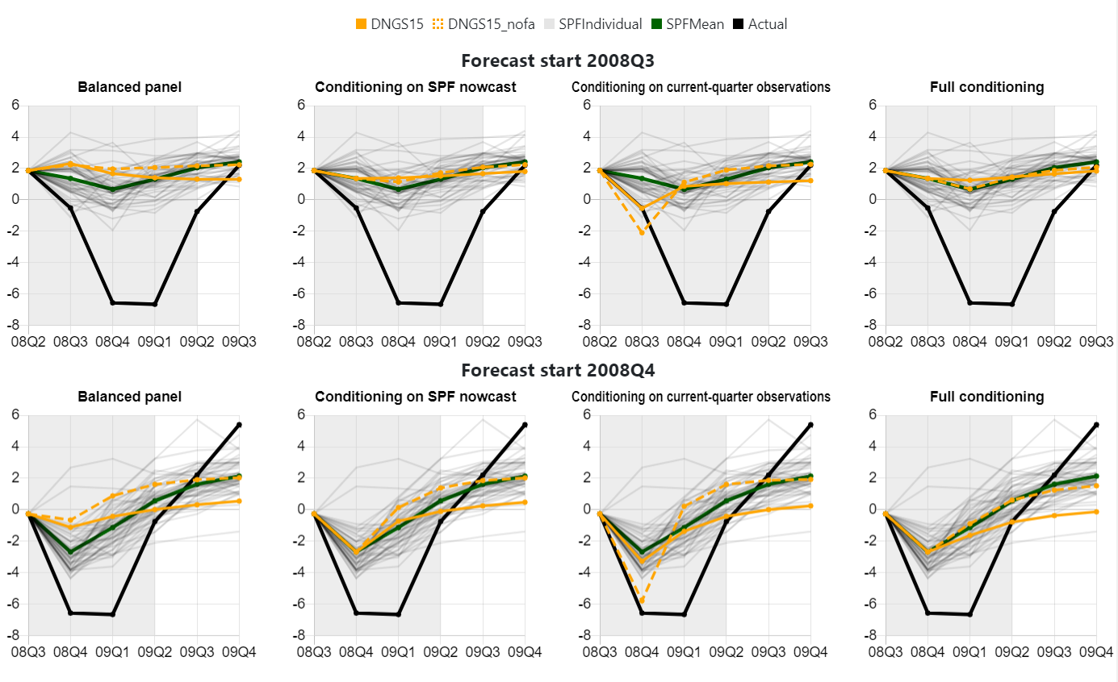

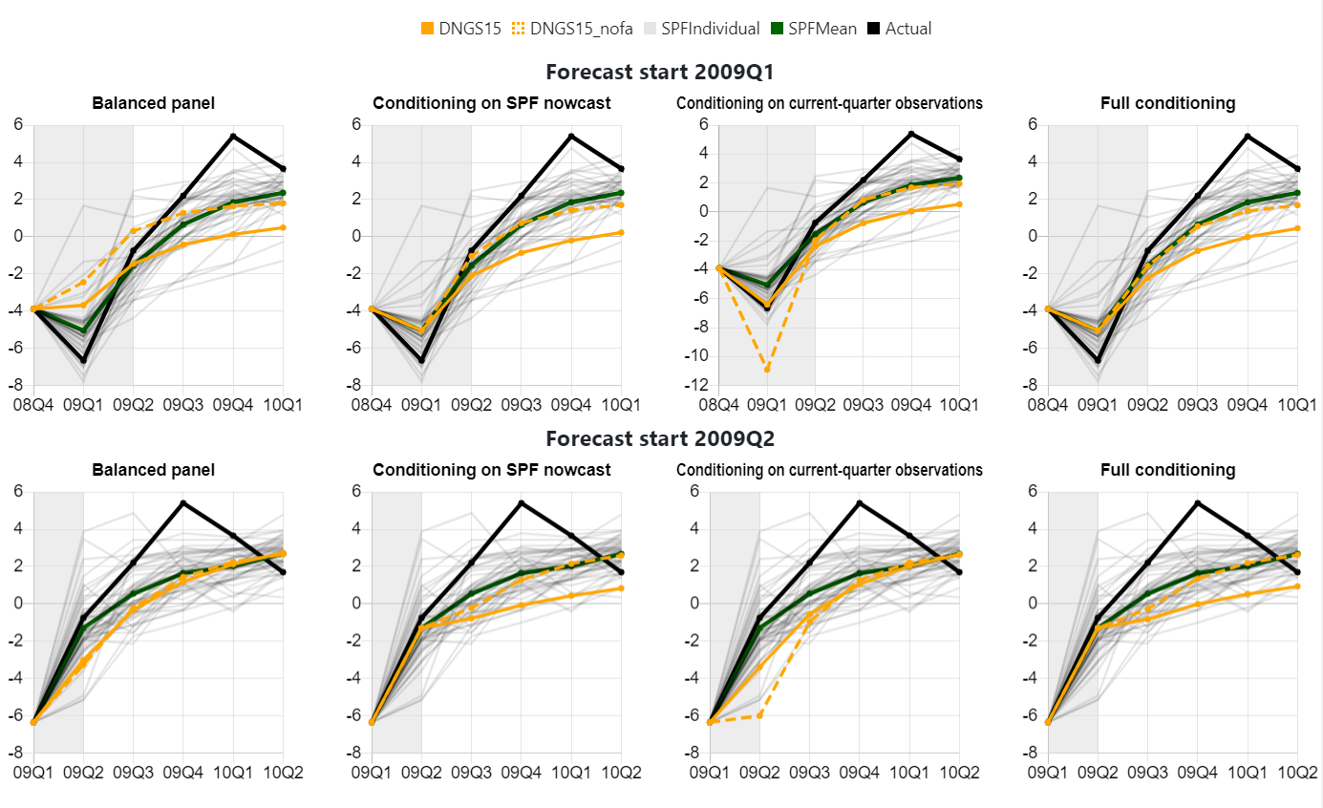

|  |  |  |  |  |  |  |  |  |  |  |
| --- | --- | --- | --- | --- | --- | --- | --- | --- | --- | --- |
| Source | | DNGS15 | | | | DNGS15_nofa | | | | SPF |
| Scenario | | BP | SPF | CQ | FC | BP | SPF | CQ | FC |  |
| Horizon | 0 | 1.55 |  | 0.91 |  | 1.50 |  | 1.76 |  | 2.32 |
| 1 | 1.15 | 1.13 | 1.04 | 1.07 | 1.17 | 1.04 | 1.26 | 1.14 | 4.64 |
| 2 | 1.05 | 1.14 | 1.03 | 1.13 | 1.09 | 1.03 | 1.09 | 1.07 | 4.52 |
| 3 | 1.27 | 1.48 | 1.30 | 1.48 | 1.02 | 1.06 | 1.03 | 1.06 | 2.42 |
| 4 | 1.63 | 1.66 | 1.69 | 1.76 | 1.09 | 1.22 | 1.08 | 1.10 | 1.83 |

* **Comparison of forecast and relative* RMSEs from models estimated based on rolling-window* and expanding-window* specifications**
* **Models: DNGS15, SW07**
* **Forecast period: 2001:I – 2001: IV, 2008: III – 2009: IV, 2020: I – 2020: II**

* RMSEs are reported relative to those of the RMSE of the mean SPF forecast, for which absolute RMSEs are reported in the last column.

* In the rolling window specification, the size of each sample is fixed to 100

* In the expanding window specification, the start of the in-sample period is fixed to 1964:I

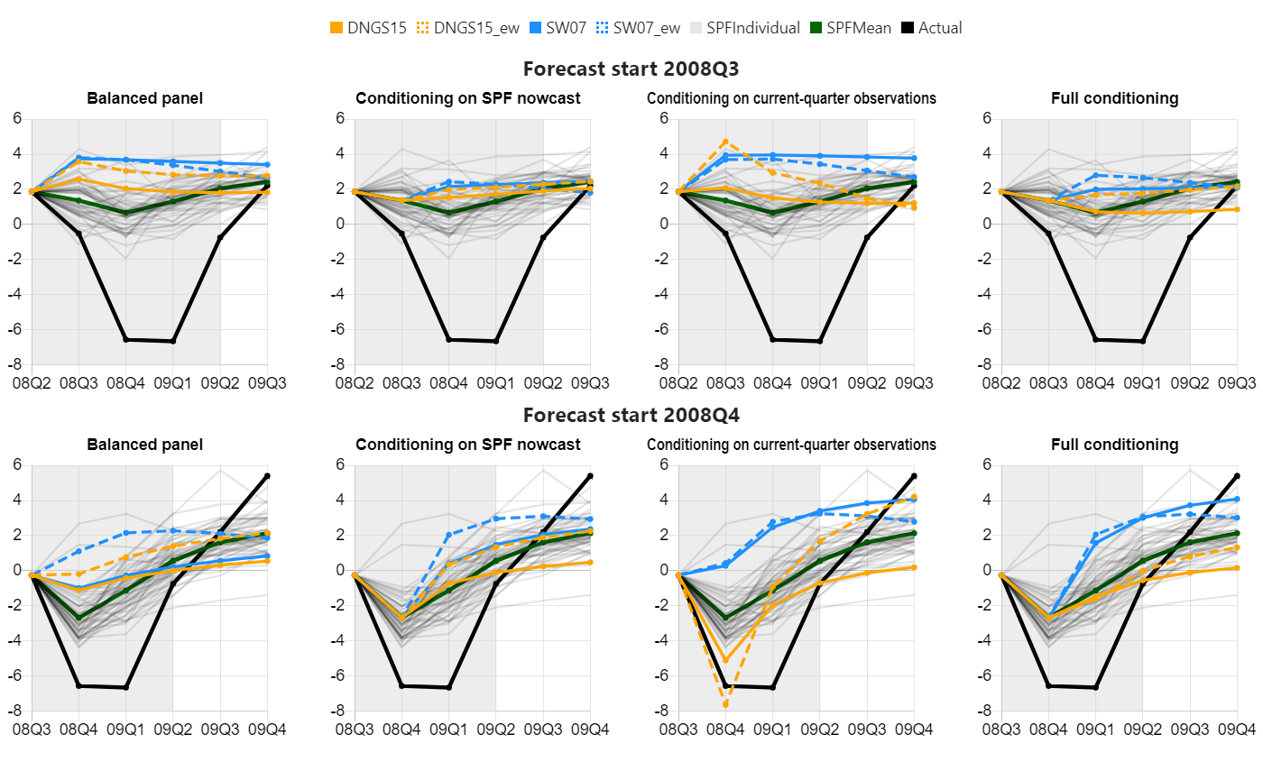

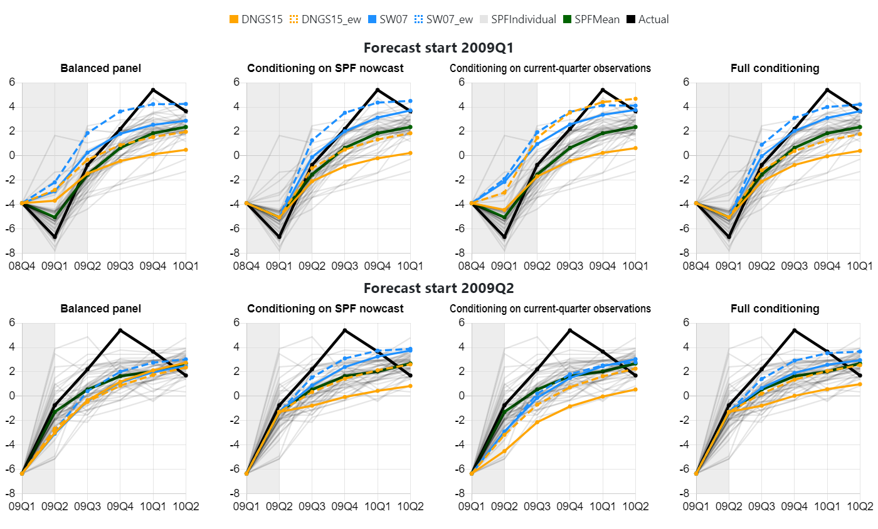

|  |  |  |  |  |  |  |  |  |  |  |  |  |  |  |  |  |  |  |
| --- | --- | --- | --- | --- | --- | --- | --- | --- | --- | --- | --- | --- | --- | --- | --- | --- | --- | --- |
| Forecast period: 2001:I - 2001:IV | | | | | | | | | | | | | | | | | | |
| Source | | DNGS15 | | | | DNGS15_ew | | | | SW07 | | | | SW07_ew | | | | SPFM |
| Scenario | | NoExt | SPF | CQ | FV | NoExt | SPF | CQ | FV | NoExt | SPF | CQ | FV | NoExt | SPF | CQ | FV |
| Forecast Horizon | 0 | 0.71 |  | 0.98 |  | 1.06 |  | 1.34 |  | 0.64 |  | 0.66 |  | 0.91 |  | 0.88 |  | 2.34 |
| 1 | 0.99 | 0.97 | 1.08 | 1.05 | 0.98 | 0.94 | 1.07 | 1.03 | 0.68 | 0.66 | 0.69 | 0.69 | 0.73 | 0.78 | 0.78 | 0.74 | 3.05 |
| 2 | 1.00 | 0.96 | 1.07 | 1.01 | 0.96 | 0.91 | 0.94 | 0.91 | 0.79 | 0.74 | 0.74 | 0.78 | 0.83 | 0.85 | 0.89 | 0.89 | 2.62 |
| 3 | 1.81 | 1.76 | 1.95 | 1.89 | 1.10 | 1.15 | 1.27 | 1.22 | 1.45 | 1.33 | 1.42 | 1.20 | 1.18 | 0.98 | 1.07 | 1.01 | 1.55 |
| 4 | 1.41 | 1.40 | 1.48 | 1.45 | 0.98 | 0.96 | 0.94 | 0.95 | 1.19 | 1.32 | 1.15 | 1.32 | 1.09 | 1.16 | 1.10 | 1.16 | 1.74 |
|  |  |  |  |  |  |  |  |  |  |  |  |  |  |  |  |  |  |  |
| Forecast period: 2008:III - 2009:IV | | | | | | | | | | | | | | | | | | |
| Source | | DNGS15 | | | | DNGS15_ew | | | | SW07 | | | | SW07_ew | | | | SPFM |
| Scenario | | NoExt | SPF | CQ | FV | NoExt | SPF | CQ | FV | NoExt | SPF | CQ | FV | NoExt | SPF | CQ | FV |
| Forecast Horizon | 0 | 1.57 |  | 1.14 |  | 1.88 |  | 1.49 |  | 1.79 |  | 2.07 |  | 2.18 |  | 2.09 |  | 2.32 |
| 1 | 1.18 | 1.14 | 1.11 | 1.03 | 1.34 | 1.21 | 1.26 | 1.07 | 1.34 | 1.22 | 1.53 | 1.29 | 1.50 | 1.37 | 1.55 | 1.39 | 4.64 |
| 2 | 1.09 | 1.16 | 1.15 | 1.05 | 1.20 | 1.11 | 1.16 | 1.06 | 1.23 | 1.07 | 1.33 | 1.12 | 1.23 | 1.11 | 1.27 | 1.15 | 4.52 |
| 3 | 1.31 | 1.50 | 1.45 | 1.41 | 1.15 | 1.10 | 0.69 | 1.11 | 1.16 | 0.80 | 1.12 | 0.85 | 0.84 | 0.64 | 0.88 | 0.74 | 2.42 |
| 4 | 1.61 | 1.66 | 1.70 | 1.74 | 1.03 | 1.03 | 0.57 | 1.25 | 1.33 | 1.00 | 0.67 | 0.50 | 1.05 | 0.93 | 0.80 | 0.86 | 1.83 |

|  |  |  |  |  |  |  |  |  |  |  |  |  |  |  |  |  |  |  |  |  |  |  |  |  |  |  |
| --- | --- | --- | --- | --- | --- | --- | --- | --- | --- | --- | --- | --- | --- | --- | --- | --- | --- | --- | --- | --- | --- | --- | --- | --- | --- | --- |
| Source | | SW07 | | | | DS04 | | | | WW11 | | | | FU20 | | | | GSW12 | | | | FRBEDO08 | | | | Fair |
| Scenario | | BP | SPF | CQ | FC | BP | SPF | CQ | FC | BP | SPF | CQ | FC | BP | SPF | CQ | FC | BP | SPF | CQ | FC | BP | SPF | CQ | FC |  |
| Horizon | 0 | 0.71 |  | 0.74 |  | 0.81 |  | 1.02 |  | 0.96 |  | 1.12 |  | 0.63 |  | 0.66 |  | 0.85 |  | 1.52 |  | 0.71 |  | 1.06 |  | 1.16 |
| 1 | 0.70 | 0.67 | 0.70 | 0.70 | 0.94 | 0.96 | 0.97 | 1.03 | 0.95 | 0.96 | 0.95 | 1.00 | 0.64 | 0.71 | 0.72 | 0.72 | 0.99 | 0.91 | 0.74 | 0.79 | 0.85 | 0.99 | 0.94 | 0.97 | 1.01 |
| 2 | 0.79 | 0.74 | 0.73 | 0.78 | 0.96 | 0.91 | 0.96 | 0.91 | 0.97 | 0.93 | 0.97 | 0.92 | 0.78 | 0.74 | 0.75 | 0.73 | 0.84 | 0.88 | 0.80 | 0.83 | 0.97 | 0.89 | 0.94 | 0.91 | 0.78 |
| 3 | 0.90 | 0.83 | 0.88 | 0.75 | 0.66 | 0.69 | 0.71 | 0.76 | 0.64 | 0.67 | 0.67 | 0.72 | 0.88 | 0.82 | 0.82 | 0.76 | 0.87 | 0.65 | 0.93 | 0.84 | 0.66 | 0.75 | 0.70 | 0.70 | 0.89 |
| 4 | 0.81 | 0.90 | 0.79 | 0.90 | 0.61 | 0.61 | 0.61 | 0.61 | 0.61 | 0.61 | 0.60 | 0.59 | 0.90 | 0.93 | 0.88 | 0.90 | 1.16 | 1.14 | 1.14 | 1.12 | 0.62 | 0.61 | 0.61 | 0.62 | 0.79 |
|  |  |  |  |  |  |  |  |  |  |  |  |  |  |  |  |  |  |  |  |  |  |  |  |  |  |  |
| Source | | NKBGG | | | | QPM08 | | | | DNGS15 | | | | CMR14 | | | | KR15_FF | | | | KR15_HH | | | |  |
| Scenario | | BP | SPF | CQ | FC | BP | SPF | CQ | FC | BP | SPF | CQ | FC | BP | SPF | CQ | FC | BP | SPF | CQ | FC | BP | SPF | CQ | FC |  |
| Horizon | 0 | 0.59 |  | 0.73 |  | 0.75 |  | 0.98 |  | 0.80 |  | 1.25 |  | 0.56 |  | 0.74 |  | 0.79 |  | 1.55 |  | 0.79 |  | 0.84 |  |  |
| 1 | 0.77 | 0.83 | 0.81 | 0.88 | 0.75 | 0.69 | 0.69 | 0.73 | 1.00 | 0.99 | 1.09 | 1.07 | 0.86 | 0.96 | 0.92 | 1.02 | 1.01 | 1.24 | 1.12 | 1.24 | 1.02 | 1.24 | 0.72 | 1.24 |  |
| 2 | 0.81 | 0.82 | 0.79 | 0.79 | 0.87 | 0.95 | 0.85 | 0.86 | 1.00 | 0.96 | 1.06 | 1.01 | 0.98 | 0.88 | 0.93 | 0.92 | 0.91 | 0.82 | 0.98 | 0.86 | 0.88 | 0.67 | 0.98 | 0.92 |  |
| 3 | 0.77 | 0.75 | 0.80 | 0.78 | 0.57 | 0.63 | 0.55 | 0.50 | 1.13 | 1.10 | 1.23 | 1.20 | 0.98 | 1.02 | 1.04 | 1.06 | 0.74 | 0.65 | 0.69 | 0.67 | 0.70 | 0.77 | 0.52 | 0.64 |  |
| 4 | 0.80 | 0.80 | 0.80 | 0.80 | 0.71 | 0.75 | 0.73 | 0.76 | 0.96 | 0.96 | 1.00 | 0.98 | 0.81 | 0.84 | 0.82 | 0.81 | 0.73 | 0.74 | 0.76 | 0.75 | 0.96 | 0.88 | 0.65 | 0.63 |  |
|  |  |  |  |  |  |  |  |  |  |  |  |  |  |  |  |  |  |  |  |  |  |  |  |  |  |  |
| Source | | IN10 | | | | VI16_BGG | | | | VI16_GK | | | | 3vBVAR | | | | 5vBVAR | | | | 8vBVAR | | | | Models |
| Scenario | | BP | SPF | CQ | FC | BP | SPF | CQ | FC | BP | SPF | CQ | FC | BP | SPF | CQ | FC | BP | SPF | CQ | FC | BP | SPF | CQ | FC | Mean |
| Horizon | 0 | 0.90 |  | 1.59 |  | 1.43 |  | 1.53 |  | 1.57 |  | 1.64 |  | 1.60 |  | 1.30 |  | 1.32 |  | 0.95 |  | 0.91 |  | 0.84 |  | 2.09 |
| 1 | 1.32 |  | 1.32 |  | 1.63 | 1.30 | 1.65 | 1.30 | 1.70 | 1.34 | 1.71 | 1.36 | 1.14 | 1.11 | 1.21 | 1.16 | 1.19 | 1.16 | 1.21 | 1.19 | 0.97 | 0.95 | 1.05 | 1.07 | 2.99 |
| 2 | 1.41 |  | 1.39 |  | 1.83 | 1.42 | 1.86 | 1.44 | 1.90 | 1.45 | 1.91 | 1.49 | 1.31 | 1.27 | 1.41 | 1.30 | 1.35 | 1.26 | 1.45 | 1.32 | 1.17 | 1.19 | 1.15 | 1.06 | 2.64 |
| 3 | 1.72 |  | 1.60 |  | 2.23 | 1.96 | 2.28 | 1.99 | 2.29 | 1.97 | 2.31 | 2.04 | 0.86 | 0.82 | 0.93 | 0.87 | 0.84 | 0.83 | 0.92 | 0.88 | 0.74 | 0.80 | 0.73 | 0.77 | 2.50 |
| 4 | 1.64 |  | 1.48 |  | 2.17 | 1.97 | 2.21 | 2.00 | 2.19 | 1.98 | 2.21 | 2.02 | 0.91 | 0.96 | 1.10 | 1.06 | 0.90 | 0.92 | 1.06 | 1.09 | 0.73 | 0.93 | 0.84 | 0.80 | 2.55 |

|  |  |  |  |  |  |  |  |  |  |  |  |  |  |  |  |  |  |  |  |  |  |  |  |  |  |  |
| --- | --- | --- | --- | --- | --- | --- | --- | --- | --- | --- | --- | --- | --- | --- | --- | --- | --- | --- | --- | --- | --- | --- | --- | --- | --- | --- |
| Source | | SW07 | | | | DS04 | | | | WW11 | | | | FU20 | | | | GSW12 | | | | FRBEDO08 | | | | Fair |
| Scenario | | BP | SPF | CQ | FC | BP | SPF | CQ | FC | BP | SPF | CQ | FC | BP | SPF | CQ | FC | BP | SPF | CQ | FC | BP | SPF | CQ | FC |  |
| Horizon | 0 | 0.83 |  | 0.98 |  | 0.99 |  | 1.29 |  | 1.12 |  | 1.36 |  | 1.13 |  | 1.02 |  | 0.89 |  | 0.80 |  | 1.18 |  | 0.89 |  | 0.90 |
| 1 | 1.00 | 0.94 | 1.18 | 1.05 | 1.01 | 0.94 | 0.98 | 0.86 | 1.05 | 1.00 | 1.03 | 0.94 | 1.20 | 1.07 | 1.22 | 1.12 | 1.01 | 0.88 | 1.02 | 0.99 | 1.12 | 1.01 | 1.08 | 0.88 | 1.01 |
| 2 | 0.99 | 0.90 | 1.11 | 1.02 | 0.97 | 0.94 | 0.97 | 0.94 | 0.97 | 0.96 | 0.96 | 0.95 | 1.12 | 1.03 | 1.15 | 1.07 | 0.89 | 0.79 | 0.87 | 0.87 | 1.04 | 1.01 | 1.13 | 0.87 | 1.04 |
| 3 | 0.90 | 0.67 | 0.92 | 0.86 | 0.92 | 0.94 | 0.94 | 1.01 | 0.87 | 0.90 | 0.89 | 0.94 | 0.91 | 0.87 | 0.92 | 0.95 | 0.60 | 0.45 | 0.64 | 0.52 | 0.73 | 0.78 | 1.15 | 0.87 | 1.00 |
| 4 | 0.99 | 0.77 | 0.51 | 0.46 | 0.75 | 0.79 | 0.81 | 0.90 | 0.68 | 0.71 | 0.74 | 0.79 | 0.64 | 0.68 | 0.56 | 0.57 | 1.01 | 1.02 | 0.73 | 0.81 | 0.78 | 0.68 | 0.98 | 0.85 | 0.76 |
|  |  |  |  |  |  |  |  |  |  |  |  |  |  |  |  |  |  |  |  |  |  |  |  |  |  |  |
| Source | | NKBGG | | | | QPM08 | | | | DNGS15 | | | | CMR14 | | | | KR15_FF | | | | KR15_HH | | | |  |
| Scenario | | BP | SPF | CQ | FC | BP | SPF | CQ | FC | BP | SPF | CQ | FC | BP | SPF | CQ | FC | BP | SPF | CQ | FC | BP | SPF | CQ | FC |  |
| Horizon | 0 | 1.16 |  | 1.16 |  | 1.21 |  | 1.13 |  | 0.73 |  | 0.43 |  | 0.96 |  | 0.67 |  | 0.94 |  | 1.37 |  | 0.94 |  | 1.24 |  |  |
| 1 | 1.13 | 1.04 | 1.07 | 0.98 | 1.03 | 1.00 | 1.00 | 1.00 | 0.88 | 0.87 | 0.80 | 0.82 | 1.09 | 0.97 | 0.96 | 0.91 | 1.19 | 0.87 | 1.20 | 1.10 | 1.14 | 0.87 | 1.25 | 0.87 |  |
| 2 | 0.99 | 0.97 | 0.98 | 0.97 | 0.89 | 0.90 | 0.88 | 0.92 | 0.88 | 0.96 | 0.86 | 0.94 | 1.16 | 1.05 | 1.11 | 1.03 | 1.02 | 0.88 | 1.02 | 0.92 | 1.11 | 0.90 | 1.28 | 1.06 |  |
| 3 | 0.76 | 0.77 | 0.76 | 0.77 | 0.71 | 0.71 | 0.66 | 0.71 | 1.05 | 1.22 | 1.08 | 1.22 | 1.14 | 1.10 | 1.16 | 1.14 | 0.72 | 0.70 | 0.75 | 0.66 | 0.86 | 1.02 | 1.21 | 1.05 |  |
| 4 | 0.67 | 0.66 | 0.67 | 0.65 | 0.96 | 0.87 | 0.97 | 0.88 | 1.25 | 1.27 | 1.30 | 1.35 | 0.72 | 0.71 | 0.85 | 0.87 | 0.63 | 0.67 | 0.67 | 0.66 | 1.06 | 1.62 | 1.14 | 1.39 |  |
|  |  |  |  |  |  |  |  |  |  |  |  |  |  |  |  |  |  |  |  |  |  |  |  |  |  |  |
| Source | | IN10 | | | | VI16_BGG | | | | VI16_GK | | | | 3vBVAR | | | | 5vBVAR | | | | 8vBVAR | | | | Models |
| Scenario | | BP | SPF | CQ | FC | BP | SPF | CQ | FC | BP | SPF | CQ | FC | BP | SPF | CQ | FC | BP | SPF | CQ | FC | BP | SPF | CQ | FC | Mean |
| Horizon | 0 | 0.70 |  | 0.93 |  | 1.04 |  | 0.99 |  | 1.04 |  | 0.99 |  | 1.22 |  | 1.24 |  | 1.18 |  | 1.07 |  | 0.96 |  | 0.85 |  | 4.90 |
| 1 | 0.76 |  | 0.76 |  | 1.13 | 0.85 | 1.14 | 0.87 | 1.09 | 0.82 | 1.12 | 0.82 | 1.06 | 0.97 | 1.05 | 0.97 | 1.11 | 0.98 | 1.05 | 0.97 | 1.11 | 1.04 | 1.09 | 1.01 | 6.02 |
| 2 | 0.77 |  | 0.76 |  | 1.34 | 1.06 | 1.32 | 1.05 | 1.29 | 0.96 | 1.29 | 0.95 | 1.08 | 0.99 | 1.03 | 0.97 | 1.17 | 1.07 | 1.12 | 1.04 | 1.17 | 1.10 | 1.16 | 1.07 | 5.39 |
| 3 | 0.78 |  | 0.82 |  | 2.06 | 1.75 | 2.01 | 1.73 | 1.88 | 1.51 | 1.86 | 1.49 | 1.22 | 1.17 | 1.15 | 1.10 | 1.51 | 1.43 | 1.47 | 1.31 | 1.48 | 1.37 | 1.52 | 1.29 | 2.93 |
| 4 | 0.85 |  | 0.92 |  | 2.19 | 1.99 | 2.16 | 2.00 | 1.99 | 1.73 | 1.95 | 1.76 | 0.93 | 1.16 | 0.90 | 1.12 | 1.36 | 1.43 | 1.38 | 1.33 | 1.28 | 1.24 | 1.35 | 1.17 | 2.38 |

|  |  |  |  |  |  |  |  |  |  |  |  |  |  |  |  |  |  |  |  |  |  |  |  |  |  |  |
| --- | --- | --- | --- | --- | --- | --- | --- | --- | --- | --- | --- | --- | --- | --- | --- | --- | --- | --- | --- | --- | --- | --- | --- | --- | --- | --- |
| Source | | SW07 | | | | DS04 | | | | WW11 | | | | FU20 | | | | GSW12 | | | | FRBEDO08 | | | | Fair |
| Scenario | | BP | SPF | CQ | FC | BP | SPF | CQ | FC | BP | SPF | CQ | FC | BP | SPF | CQ | FC | BP | SPF | CQ | FC | BP | SPF | CQ | FC |  |
| Horizon | 0 | 0.98 |  | 1.02 |  | 1.12 |  | 1.41 |  | 1.32 |  | 1.54 |  | 0.86 |  | 0.91 |  | 1.16 |  | 2.09 |  | 0.98 |  | 1.46 |  | 1.60 |
| 1 | 1.01 | 0.97 | 1.01 | 1.02 | 1.35 | 1.39 | 1.40 | 1.49 | 1.37 | 1.39 | 1.38 | 1.44 | 0.92 | 1.03 | 1.04 | 1.03 | 1.43 | 1.31 | 1.06 | 1.13 | 1.22 | 1.43 | 1.35 | 1.41 | 1.46 |
| 2 | 1.04 | 0.97 | 0.96 | 1.03 | 1.27 | 1.19 | 1.26 | 1.20 | 1.28 | 1.22 | 1.27 | 1.22 | 1.03 | 0.97 | 0.99 | 0.96 | 1.11 | 1.16 | 1.06 | 1.10 | 1.27 | 1.17 | 1.24 | 1.19 | 1.03 |
| 3 | 1.07 | 0.98 | 1.05 | 0.89 | 0.79 | 0.82 | 0.85 | 0.91 | 0.77 | 0.79 | 0.80 | 0.85 | 1.05 | 0.98 | 0.98 | 0.91 | 1.03 | 0.77 | 1.10 | 1.00 | 0.79 | 0.89 | 0.83 | 0.83 | 1.06 |
| 4 | 0.96 | 1.06 | 0.93 | 1.06 | 0.72 | 0.72 | 0.71 | 0.71 | 0.72 | 0.71 | 0.71 | 0.70 | 1.06 | 1.09 | 1.03 | 1.06 | 1.37 | 1.33 | 1.34 | 1.31 | 0.73 | 0.71 | 0.71 | 0.73 | 0.93 |
|  |  |  |  |  |  |  |  |  |  |  |  |  |  |  |  |  |  |  |  |  |  |  |  |  |  |  |
| Source | | NKBGG | | | | QPM08 | | | | DNGS15 | | | | CMR14 | | | | KR15_FF | | | | KR15_HH | | | |  |
| Scenario | | BP | SPF | CQ | FC | BP | SPF | CQ | FC | BP | SPF | CQ | FC | BP | SPF | CQ | FC | BP | SPF | CQ | FC | BP | SPF | CQ | FC |  |
| Horizon | 0 | 0.82 |  | 1.01 |  | 1.04 |  | 1.34 |  | 1.10 |  | 1.72 |  | 0.76 |  | 1.02 |  | 1.09 |  | 2.13 |  | 1.09 |  | 1.16 |  |  |
| 1 | 1.11 | 1.21 | 1.17 | 1.27 | 1.09 | 0.99 | 1.00 | 1.05 | 1.45 | 1.43 | 1.58 | 1.54 | 1.25 | 1.39 | 1.33 | 1.48 | 1.46 | 1.79 | 1.61 | 1.79 | 1.48 | 1.79 | 1.04 | 1.79 |  |
| 2 | 1.07 | 1.08 | 1.04 | 1.05 | 1.15 | 1.25 | 1.12 | 1.13 | 1.31 | 1.26 | 1.40 | 1.33 | 1.29 | 1.16 | 1.22 | 1.22 | 1.19 | 1.08 | 1.29 | 1.13 | 1.15 | 0.88 | 1.30 | 1.21 |  |
| 3 | 0.91 | 0.90 | 0.95 | 0.93 | 0.67 | 0.75 | 0.65 | 0.59 | 1.34 | 1.30 | 1.46 | 1.42 | 1.17 | 1.21 | 1.24 | 1.27 | 0.88 | 0.77 | 0.82 | 0.79 | 0.83 | 0.92 | 0.62 | 0.77 |  |
| 4 | 0.94 | 0.94 | 0.94 | 0.94 | 0.83 | 0.88 | 0.86 | 0.89 | 1.13 | 1.12 | 1.17 | 1.15 | 0.95 | 0.99 | 0.96 | 0.95 | 0.86 | 0.86 | 0.90 | 0.88 | 1.13 | 1.03 | 0.76 | 0.74 |  |
|  |  |  |  |  |  |  |  |  |  |  |  |  |  |  |  |  |  |  |  |  |  |  |  |  |  |  |
| Source | | IN10 | | | | VI16_BGG | | | | VI16_GK | | | | 3vBVAR | | | | 5vBVAR | | | | 8vBVAR | | | | SW07 |
| Scenario | | BP | SPF | CQ | FC | BP | SPF | CQ | FC | BP | SPF | CQ | FC | BP | SPF | CQ | FC | BP | SPF | CQ | FC | BP | SPF | CQ | FC | Mean |
| Horizon | 0 | 1.24 |  | 2.19 |  | 1.97 |  | 2.10 |  | 2.16 |  | 2.26 |  | 2.20 |  | 1.79 |  | 1.81 |  | 1.31 |  | 1.25 |  | 1.16 |  | 1.52 |
| 1 | 1.90 |  | 1.91 |  | 2.35 | 1.87 | 2.38 | 1.88 | 2.46 | 1.93 | 2.47 | 1.96 | 1.65 | 1.60 | 1.75 | 1.68 | 1.71 | 1.68 | 1.75 | 1.72 | 1.40 | 1.38 | 1.52 | 1.54 | 2.07 |
| 2 | 1.85 |  | 1.83 |  | 2.41 | 1.87 | 2.45 | 1.89 | 2.50 | 1.91 | 2.51 | 1.97 | 1.72 | 1.67 | 1.85 | 1.71 | 1.78 | 1.66 | 1.90 | 1.74 | 1.54 | 1.57 | 1.51 | 1.39 | 2.00 |
| 3 | 2.05 |  | 1.91 |  | 2.65 | 2.33 | 2.72 | 2.37 | 2.73 | 2.35 | 2.76 | 2.43 | 1.02 | 0.98 | 1.11 | 1.03 | 1.00 | 0.98 | 1.09 | 1.05 | 0.88 | 0.95 | 0.87 | 0.91 | 2.10 |
| 4 | 1.93 |  | 1.73 |  | 2.55 | 2.31 | 2.59 | 2.35 | 2.57 | 2.33 | 2.59 | 2.37 | 1.07 | 1.13 | 1.29 | 1.25 | 1.05 | 1.08 | 1.25 | 1.28 | 0.85 | 1.09 | 0.99 | 0.94 | 2.17 |

|  |  |  |  |  |  |  |  |  |  |  |  |  |  |  |  |  |  |  |  |  |  |  |  |  |  |  |
| --- | --- | --- | --- | --- | --- | --- | --- | --- | --- | --- | --- | --- | --- | --- | --- | --- | --- | --- | --- | --- | --- | --- | --- | --- | --- | --- |
| Source | | SW07 | | | | DS04 | | | | WW11 | | | | FU20 | | | | GSW12 | | | | FRBEDO08 | | | | Fair |
| Scenario | | BP | SPF | CQ | FC | BP | SPF | CQ | FC | BP | SPF | CQ | FC | BP | SPF | CQ | FC | BP | SPF | CQ | FC | BP | SPF | CQ | FC |  |
| Horizon | 0 | 0.92 |  | 1.08 |  | 1.10 |  | 1.43 |  | 1.24 |  | 1.51 |  | 1.25 |  | 1.13 |  | 0.99 |  | 0.88 |  | 1.31 |  | 0.98 |  | 1.00 |
| 1 | 0.96 | 0.90 | 1.13 | 1.00 | 0.97 | 0.91 | 0.94 | 0.83 | 1.01 | 0.96 | 0.99 | 0.91 | 1.15 | 1.03 | 1.17 | 1.08 | 0.97 | 0.85 | 0.98 | 0.95 | 1.07 | 0.97 | 1.04 | 0.84 | 0.97 |
| 2 | 0.99 | 0.90 | 1.10 | 1.02 | 0.96 | 0.93 | 0.96 | 0.93 | 0.96 | 0.95 | 0.96 | 0.94 | 1.12 | 1.03 | 1.14 | 1.07 | 0.88 | 0.78 | 0.87 | 0.86 | 1.03 | 1.00 | 1.13 | 0.87 | 1.03 |
| 3 | 1.07 | 0.81 | 1.10 | 1.02 | 1.10 | 1.12 | 1.13 | 1.21 | 1.04 | 1.08 | 1.06 | 1.12 | 1.09 | 1.04 | 1.11 | 1.14 | 0.72 | 0.54 | 0.76 | 0.62 | 0.88 | 0.93 | 1.38 | 1.05 | 1.19 |
| 4 | 1.46 | 1.13 | 0.75 | 0.67 | 1.11 | 1.15 | 1.19 | 1.32 | 1.00 | 1.04 | 1.08 | 1.16 | 0.93 | 0.99 | 0.83 | 0.83 | 1.47 | 1.49 | 1.07 | 1.19 | 1.14 | 1.00 | 1.44 | 1.24 | 1.11 |
|  |  |  |  |  |  |  |  |  |  |  |  |  |  |  |  |  |  |  |  |  |  |  |  |  |  |  |
| Source | | NKBGG | | | | QPM08 | | | | DNGS15 | | | | CMR14 | | | | KR15_FF | | | | KR15_HH | | | |  |
| Scenario | | BP | SPF | CQ | FC | BP | SPF | CQ | FC | BP | SPF | CQ | FC | BP | SPF | CQ | FC | BP | SPF | CQ | FC | BP | SPF | CQ | FC |  |
| Horizon | 0 | 1.28 |  | 1.28 |  | 1.34 |  | 1.25 |  | 0.81 |  | 0.48 |  | 1.07 |  | 0.74 |  | 1.04 |  | 1.52 |  | 1.04 |  | 1.37 |  |  |
| 1 | 1.08 | 1.00 | 1.02 | 0.94 | 0.99 | 0.96 | 0.96 | 0.96 | 0.85 | 0.83 | 0.77 | 0.79 | 1.04 | 0.93 | 0.92 | 0.87 | 1.14 | 0.83 | 1.15 | 1.06 | 1.10 | 0.83 | 1.20 | 0.83 |  |
| 2 | 0.99 | 0.97 | 0.98 | 0.96 | 0.88 | 0.89 | 0.88 | 0.91 | 0.87 | 0.95 | 0.86 | 0.94 | 1.15 | 1.04 | 1.10 | 1.02 | 1.01 | 0.87 | 1.01 | 0.91 | 1.10 | 0.89 | 1.27 | 1.05 |  |
| 3 | 0.91 | 0.92 | 0.92 | 0.93 | 0.85 | 0.85 | 0.79 | 0.85 | 1.26 | 1.46 | 1.29 | 1.47 | 1.37 | 1.31 | 1.39 | 1.36 | 0.86 | 0.84 | 0.90 | 0.80 | 1.03 | 1.22 | 1.45 | 1.26 |  |
| 4 | 0.99 | 0.97 | 0.98 | 0.95 | 1.41 | 1.28 | 1.42 | 1.29 | 1.83 | 1.87 | 1.90 | 1.98 | 1.05 | 1.04 | 1.25 | 1.27 | 0.93 | 0.98 | 0.98 | 0.97 | 1.55 | 2.37 | 1.68 | 2.03 |  |
|  |  |  |  |  |  |  |  |  |  |  |  |  |  |  |  |  |  |  |  |  |  |  |  |  |  |  |
| Source | | IN10 | | | | VI16_BGG | | | | VI16_GK | | | | 3vBVAR | | | | 5vBVAR | | | | 8vBVAR | | | | SW07 |
| Scenario | | BP | SPF | CQ | FC | BP | SPF | CQ | FC | BP | SPF | CQ | FC | BP | SPF | CQ | FC | BP | SPF | CQ | FC | BP | SPF | CQ | FC | Mean |
| Horizon | 0 | 0.78 |  | 1.03 |  | 1.15 |  | 1.09 |  | 1.15 |  | 1.10 |  | 1.35 |  | 1.37 |  | 1.30 |  | 1.18 |  | 1.07 |  | 0.94 |  | 4.42 |
| 1 | 0.73 |  | 0.73 |  | 1.08 | 0.82 | 1.09 | 0.84 | 1.05 | 0.79 | 1.07 | 0.78 | 1.02 | 0.93 | 1.01 | 0.93 | 1.07 | 0.94 | 1.01 | 0.93 | 1.06 | 1.00 | 1.04 | 0.97 | 6.27 |
| 2 | 0.76 |  | 0.75 |  | 1.33 | 1.05 | 1.31 | 1.04 | 1.28 | 0.95 | 1.28 | 0.94 | 1.07 | 0.99 | 1.02 | 0.97 | 1.16 | 1.07 | 1.11 | 1.03 | 1.16 | 1.10 | 1.16 | 1.06 | 5.43 |
| 3 | 0.93 |  | 0.98 |  | 2.47 | 2.10 | 2.41 | 2.07 | 2.26 | 1.81 | 2.23 | 1.78 | 1.46 | 1.40 | 1.37 | 1.32 | 1.81 | 1.71 | 1.76 | 1.57 | 1.78 | 1.64 | 1.82 | 1.54 | 2.45 |
| 4 | 1.24 |  | 1.35 |  | 3.21 | 2.92 | 3.17 | 2.93 | 2.92 | 2.54 | 2.86 | 2.58 | 1.37 | 1.70 | 1.32 | 1.64 | 2.00 | 2.09 | 2.02 | 1.95 | 1.88 | 1.82 | 1.97 | 1.72 | 1.63 |